# [6 Dream LAW & ORDER Franchise Crossover Pairings](https://www.givememyremote.com/remote/2022/07/14/6-dream-law-and-order-franchise-crossover-pairings/)

July 14, 2022 by [Marisa Roffman](https://www.givememyremote.com/remote/author/marisa/)

With [LAW & ORDER](https://www.givememyremote.com/remote/category/law-order/), [LAW & ORDER: SPECIAL VICTIMS UNIT](https://www.givememyremote.com/remote/category/law-order/svu/), and [LAW & ORDER: ORGANIZED CRIME](https://www.givememyremote.com/remote/category/law-order-organized-crime/) on the verge of potentially [doing the franchise’s first three-show crossover](https://www.givememyremote.com/remote/2022/07/06/law-and-order-cross-ver-svu-organized-crime-nbc/), the potential for characters meeting up feels endless. Will we get a big scene with the majority of the casts? A three-show police bust? An all-star courtroom showdown or team-up?

With so many possible variations, here are six groups whose interactions could be *very* memorable…

### **LAW & ORDER'S SAM WATERSTON, SVU'S MARISKA HARGITAY, AND OC'S CHRISTOPHER MELONI**

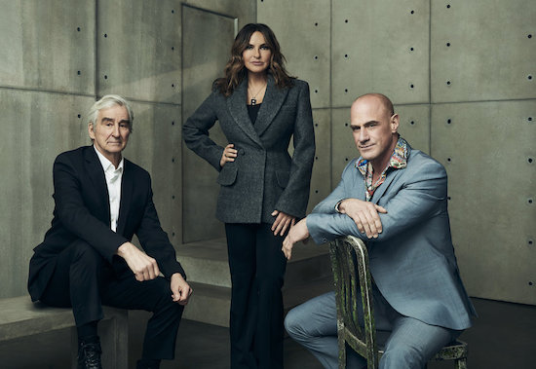

[◄ Back](https://www.givememyremote.com/remote/2022/07/14/6-dream-law-and-order-franchise-crossover-pairings/nggallery/image/law-and-order-cosgrove-and-jet/)

[Next ►](https://www.givememyremote.com/remote/2022/07/14/6-dream-law-and-order-franchise-crossover-pairings/nggallery/image/law-and-order-crossover-bosses/)

Picture 1 of 6

Combining the LAW & ORDER shows together for a cohesive crossover will be quite the feat, but dream pairing number 1 is the writers managing to get three of the franchise's biggest titans together. LAW & ORDER star [Sam Waterston](https://www.givememyremote.com/remote/2022/06/07/law-and-order-season-22-cast-sam-waterston/) has been a part of the world off-on since '94; [Mariska Hargitay](https://www.givememyremote.com/remote/2021/06/04/svu-organized-crime-benson-stabler-romance-mariska-hargitay-christopher-meloni/) and [Christopher Meloni](https://www.givememyremote.com/remote/2021/04/02/mariska-hargitay-christopher-meloni-elliot-olivia-reunion-svu-organized-crime/) joined in '99, with Hargitay notching an astonishing 23 seasons (and counting) on SVU, with Meloni appearing for a dozen seasons on SVU before headlining OC in '21. Fingers crossed the writers can find a way to get the trio in a scene together, even if it's just a beat at the end. (On the last major ONE CHICAGO crossover, [a scene was crafted for P.D.’s Voight (Beghe), MED’s Goodwin (S. Epatha Merkerson), and FIRE’s Boden (Eamonn Walker) to close out the event, but it ended up being cut](https://www.givememyremote.com/remote/2019/10/23/one-chicago-crossover-deleted-scene/).) (Photo credit: NBC)